Amrita Vishwa Vidhyapeetham – Nagercoil Campus

Department of Artificial Intelligence and Data Science

Amrita School of Computing

II Semester B.Tech. AID

23AID112 – Data Structures and Algorithms

Labsheet – 10

Project – Applications of Graph

Name:A.Pranathi
Roll no:NC.AI.U4AID25005

Abstract:
Graphs are fundamental data structures used to represent relationships between entities in a structured manner. They consist of vertices (nodes) and edges (connections) that help in modeling complex systems efficiently. This project focuses on exploring the wide range of applications of graph theory in real-world scenarios such as transportation networks, social media platforms, computer networks, and recommendation systems.
In modern computing, graphs play a crucial role in solving problems that involve connectivity, pathfinding, and optimization. For example, navigation systems use graph algorithms to determine the shortest path between locations, while social networks use graphs to analyze relationships and suggest connections. Similarly, computer networks rely on graph-based routing algorithms to ensure efficient data transmission.
This project demonstrates the implementation of important graph algorithms such as Breadth First Search (BFS), Depth First Search (DFS), and Dijkstra’s algorithm. These algorithms are used to traverse graphs, explore relationships, and find optimal paths between nodes. The project also compares their performance and effectiveness in different scenarios.
Through practical implementation and analysis, this project highlights how graph-based approaches provide efficient and scalable solutions to complex problems. It emphasizes the importance of graph theory in various domains of computer science and its growing relevance in real-world applications.
Introduction:
Graphs are one of the most important non-linear data structures in Data Structures and Algorithms (DSA). They are used to represent relationships between different entities, where each entity is represented as a vertex (node) and the connection between them is represented as an edge. Graphs provide a flexible and efficient way to model complex systems in real life.
Graphs can be classified into different types such as directed and undirected graphs, weighted and unweighted graphs, and cyclic and acyclic graphs. These variations allow graphs to be used in a wide range of applications depending on the nature of the problem.
In today’s world, graphs are widely used in many fields. For example, in navigation systems, graphs help in finding the shortest path between locations. In social media platforms, graphs are used to represent user connections and analyze relationships. In computer networks, graphs are used to model communication paths and optimize data transfer. They are also used in recommendation systems, web page ranking, and artificial intelligence.
To work with graphs effectively, several algorithms are used such as Breadth First Search (BFS), Depth First Search (DFS), and shortest path algorithms like Dijkstra’s algorithm. These algorithms help in traversing graphs, searching for nodes, and solving optimization problems.
This project aims to study the structure and types of graphs, understand their real-world applications, and implement basic graph algorithms to demonstrate their usefulness in solving practical problems.
Methodologies:
The project follows multiple methodologies to study and implement graph applications effectively. These methodologies focus on different stages of problem-solving using graph data structures and algorithms.
1.GraphRepresentation Methodology:
The problem is modeled using graphs where entities are represented as vertices and relationships as edges. Graphs are implemented using adjacency matrix and adjacency list techniques based on efficiency requirements.
2. Algorithm Design Methodology:
Standard graph algorithms such as Breadth First Search (BFS), Depth First Search (DFS), and Dijkstra’s algorithm are selected and designed to solve traversal and shortest path problems.
3. Implementation Methodology:
The designed algorithms are implemented using a programming language. Proper coding techniques are followed to ensure accuracy and efficiency.
4. Testing Methodology:
The implemented algorithms are tested using different sample inputs to verify correctness. Various scenarios are considered to check performance.
5. Analysis Methodology:
The results are analyzed based on time complexity, space usage, and efficiency. Comparisons are made to understand the effectiveness of each algorithm.
6. Application Methodology:
The algorithms are applied to real-world scenarios such as navigation systems, social networks, and computer networks to demonstrate practical usage.
These methodologies together provide a structured approach to understanding and applying graph concepts in real-world problems.
Comparison of Methodologies:
The different methodologies used in this project can be compared based on their role, complexity, and effectiveness in solving graph-related problems.
Graph Representation vs Algorithm Design:
Graph representation methodology focuses on how data is stored, while algorithm design focuses on how the data is processed. Efficient representation (like adjacency list) improves the performance of algorithms such as BFS, DFS, and Dijkstra’s.
Algorithm Design vs Implementation:
Algorithm design provides the logical steps to solve a problem, whereas implementation converts those steps into actual code. A well-designed algorithm may still perform poorly if not implemented efficiently.
Implementation vs Testing:
Implementation ensures that the algorithm is coded correctly, while testing verifies its correctness using different inputs. Testing helps identify errors and ensures the reliability of the implemented solution.
Testing vs Analysis:
Testing checks whether the program works correctly, whereas analysis evaluates how well it performs in terms of time and space complexity. Analysis helps in understanding the efficiency of the solution.
Analysis vs Application:
Analysis focuses on theoretical performance, while application demonstrates practical usage in real-world scenarios. An algorithm may be efficient theoretically but must also be practical for real-world use.
Overall Comparison:
Each methodology plays a unique role in the project. Representation supports algorithms, algorithms drive implementation, implementation is validated by testing, and analysis ensures efficiency before applying the solution to real-world problems. Together, they form a complete and effective approach to solving graph-based problems.
Results and Discussion:
The implementation of graph methodologies and algorithms produced accurate and meaningful results across different test scenarios. The graph representations using adjacency list and adjacency matrix were successfully created, and their performance differences were clearly observed. The adjacency list proved to be more efficient in terms of memory usage, especially for sparse graphs, while the adjacency matrix was simpler but consumed more space.
The traversal algorithms, Breadth First Search (BFS) and Depth First Search (DFS), were executed on sample graphs. BFS successfully explored nodes level by level and was effective in finding the shortest path in unweighted graphs. DFS, on the other hand, explored nodes deeply and was useful in identifying connected components and graph structure.
Dijkstra’s algorithm was implemented to find the shortest path in weighted graphs. The results showed that it accurately calculated the minimum distance between nodes, making it suitable for applications like navigation systems and network routing.
During testing, all algorithms produced correct outputs for different inputs. The time complexity of BFS and DFS was found to be efficient for traversal, while Dijkstra’s algorithm required more computation but provided optimal results.
The discussion highlights that the choice of methodology depends on the problem requirements. For simple traversal, BFS and DFS are sufficient, while for optimization problems involving weights, Dijkstra’s algorithm is more appropriate. Overall, the results confirm that graph-based methodologies are effective and reliable for solving real-world problems involving relationships and connectivity.

Conclusion:
This project successfully demonstrated the importance and effectiveness of graph data structures in solving real-world problems. By studying different methodologies such as graph representation, algorithm design, implementation, testing, and analysis, a clear understanding of how graphs are used in practical applications was achieved.
The implementation of algorithms like Breadth First Search (BFS), Depth First Search (DFS), and Dijkstra’s algorithm showed that graphs can efficiently handle problems related to traversal, connectivity, and shortest path finding. Each algorithm proved useful for specific types of problems, highlighting the need to choose the right approach based on requirements.
The comparison of methodologies and analysis of results emphasized that both theoretical understanding and practical implementation are essential for developing efficient solutions. The project also showed that graph-based approaches are widely applicable in areas such as navigation systems, social networks, and computer networks.
Overall, the project concludes that graph theory is a powerful tool in computer science, providing scalable and efficient solutions for complex problems involving relationships and connections.
References:
- Cormen, T. H., Leiserson, C. E., Rivest, R. L., & Stein, C.
“Introduction to Algorithms”, 3rd Edition, MIT Press, 2009.
- Weiss, M. A.
“Data Structures and Algorithm Analysis in C++”, Pearson Education, 2014.
- Goodrich, M. T., Tamassia, R., & Goldwasser, M. H.
“Data Structures and Algorithms in Java”, Wiley, 2014.
- Sedgewick, R., & Wayne, K.
“Algorithms”, 4th Edition, Addison-Wesley, 2011.
- Kumar, A., & Singh, P. (2023)
“Efficient Shortest Path Algorithms for Road Networks”, International Journal of Computer Science.
- Sharma, R., & Gupta, S. (2022)
“Graph-Based Social Network Analysis Using Machine Learning”, Journal of Data Science.
- Patel, D., & Mehta, K. (2024)
“Routing Optimization in Computer Networks Using Graph Theory”, International Journal of Networking.
- Lee, J., & Kim, H. (2023)
“Applications of Graph Theory in Recommendation Systems”, IEEE Access.
- Zhang, Y., & Liu, X. (2024)
“Graph Algorithms in Artificial Intelligence Systems”, ACM Computing Surveys.
- GeeksforGeeks
“Graph Data Structure and Algorithms”, Available online.
Problems:
- Write a C program to apply Warshall’s and Floyd‘s algorithms for constructing the shortest path.
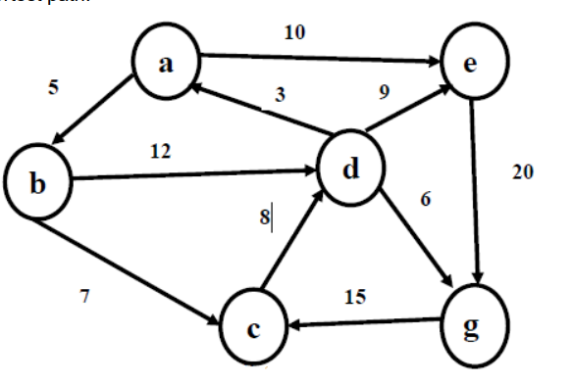

Program:
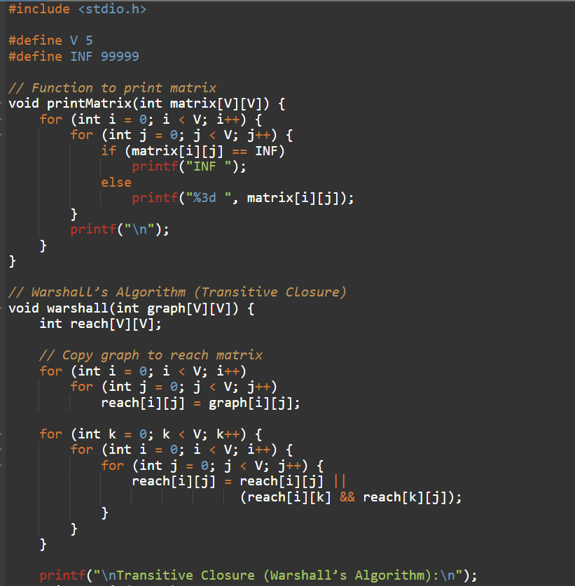
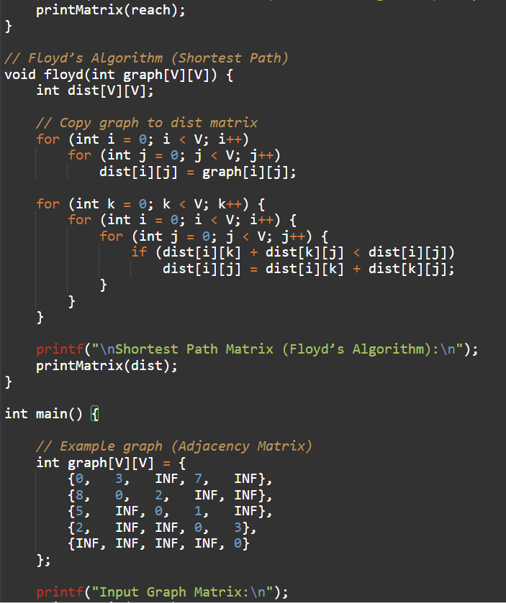
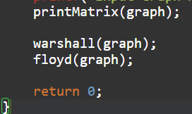

Output:
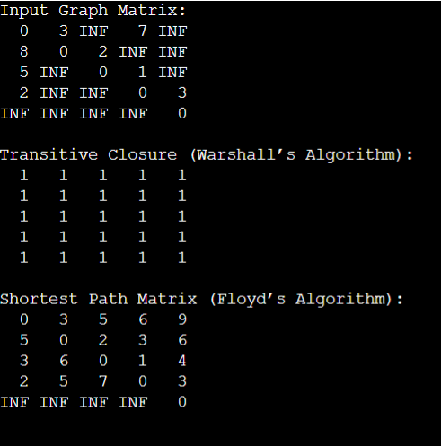
- Develop a C program to implement Dijkstra’s algorithm using Greedy Technique.
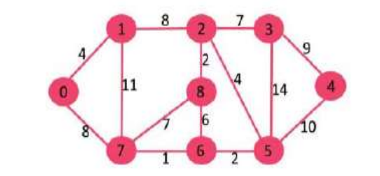
Program:
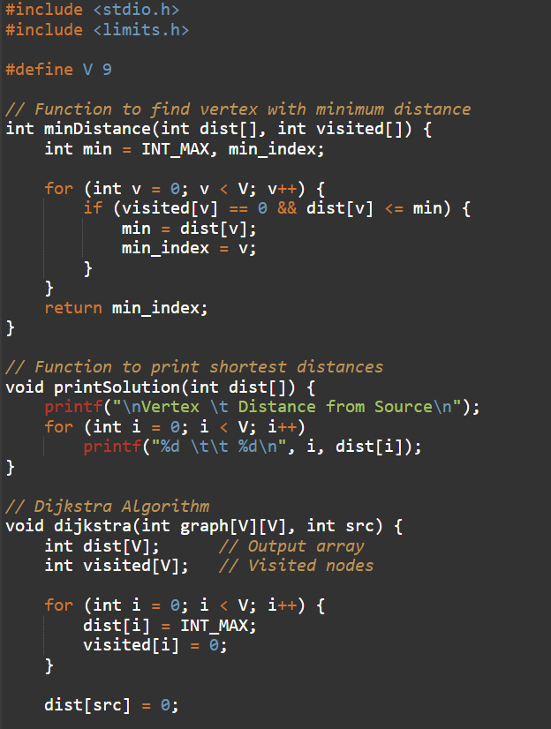
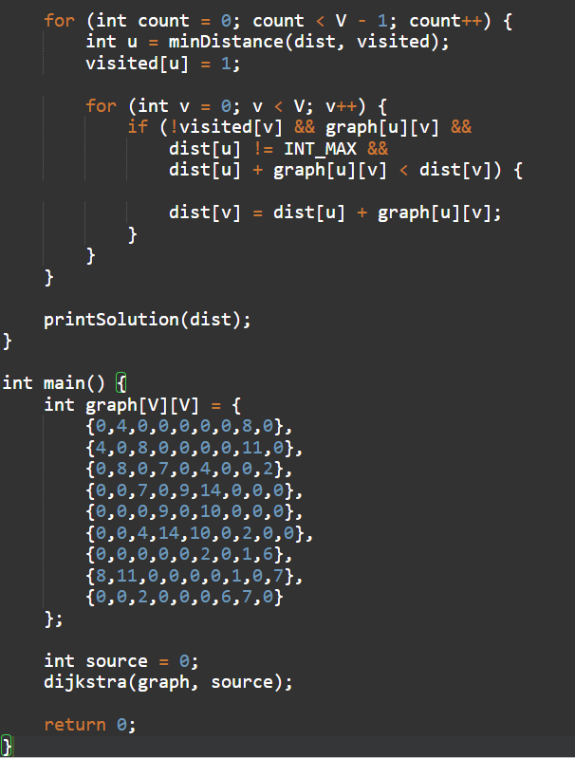
Output:
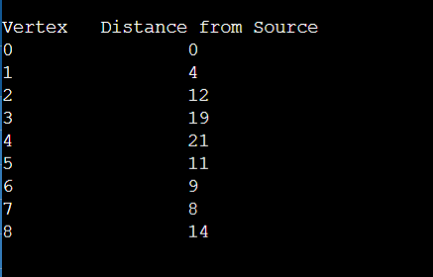
- Develop a C program to implement Bellman – Ford algorithm for the following graph.
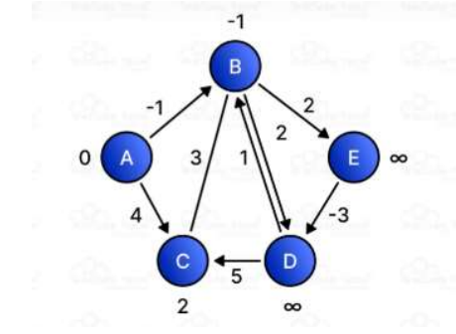
Program:
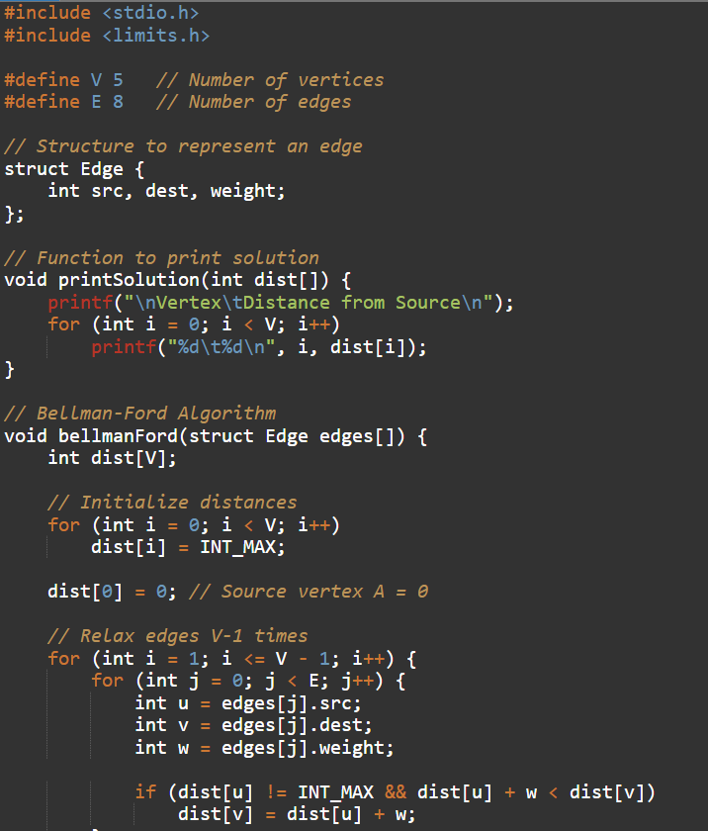
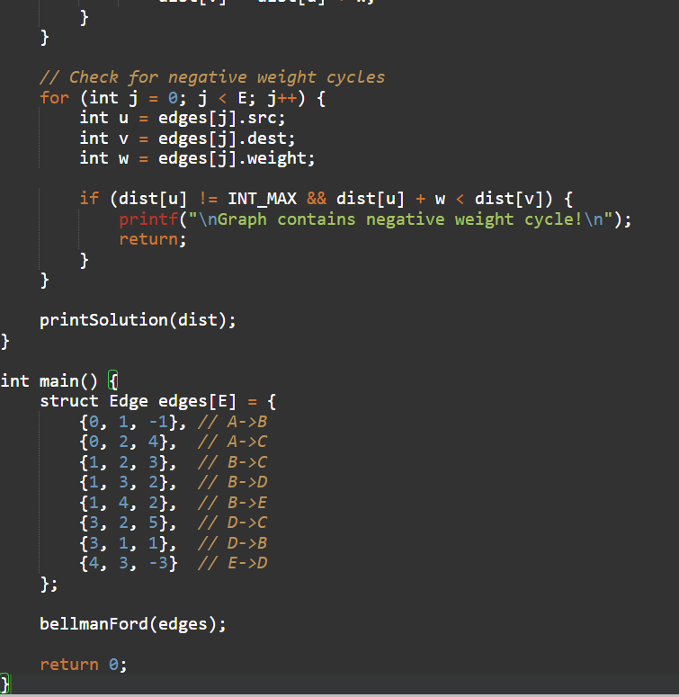
Output:
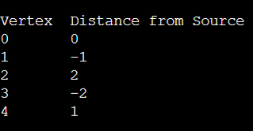
GitHub Link:

